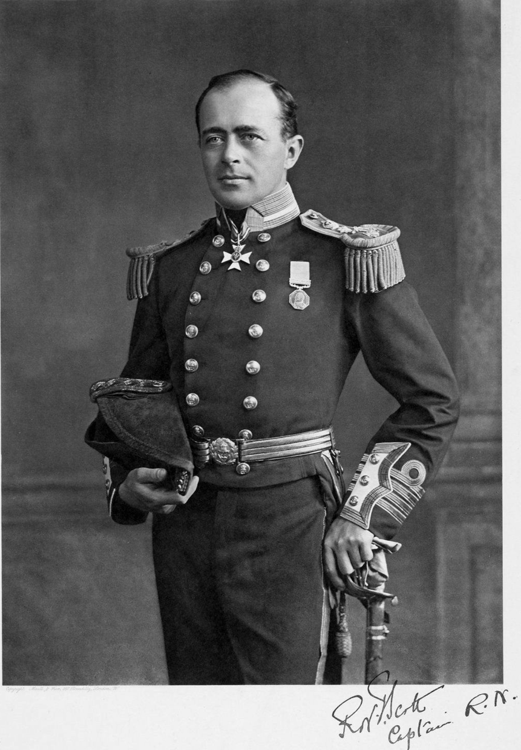

Robert Scott was born in 1868 on June 6th in Plymouth and was the third oldest out of six children. Robert Scott was a royal navy officer and explorer who led two expeditions to the Antarctic regions. He had led a party made up of five people who reached the South Pole on 17 January 1912, less than five weeks after Amundsen’s South Pole expedition. Scott died aged 44 in 1912 of heart disease when he was out travelling the sea. He started is naval career in 1881 as a thirteen year old cadet. Robert Scott was part of the discovery expedition in 1901-1904. Scott was given overall command and was promoted to the rank of commander before discovery sailed for the Atlantic on August 6th 1901. Experience of the Antarctic and Arctic was almost entirely lacking within the 50-stong party and there was very little special training in equipment or techniques.

