Greenfield Primary School Curriculum Overview 2024-25
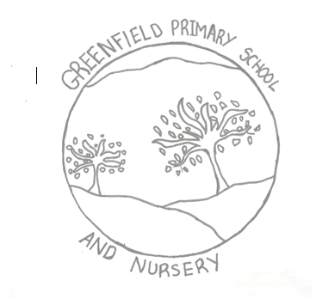 | Nursery
 | Autumn 1 | Autumn 2 | Spring 1 | Spring 2 | Summer 1 | Summer 2
Literacy | Mark making and developing a love for books | Mark making and developing a love for books | Language-rich environment- developing awareness of print | Recognising some symbols, letters and words of significance | Giving meaning to marks  Writing recognisable letters in name
Mathematics | Colour and patterns  Says some number names in order. | Number songs.  Counts forwards and backwards to 5 | Counting objects with 1-1 correspondence | Recognising numerals | Matching quantity to numeral to 10 | Matching quantity to numeral to 10 and beyond 10
Understanding of the World | Ourselves- Who am I? | Autumn/ Celebrations/light and dark | Walking through the jungle/dinosaurs | ICT- how can I make things work? | Living things. How do things grow and change? | Pets/vets Growing up and moving on.
Expressive Arts and Design | Singing songs | Matching movement to music | Taking on a role within play. Showing own preferences and strengths. |  | Creates in a range of ways, planning ahead using problem solving skills to achieve desired effect.
Personal, Social and Emotional Development | Developing relationships | Developing confidence | Developing independence | Understanding and respecting others | Playing games and following rules | Being proud and sharing our achievements
Physical Development | Accessing the Nursery environment safely |  | Accessing learning with increasing independence and resilience |  | Becoming confident in drawing, writing, climbing, running and using a range of large and small equipment.
Communication and Language | Sharing ideas | Listening to others | Forming relevant responses | Creative a narrative for their own play | Talk about events using a range of tenses | Taking on board the ideas of others
SMSC, PSHE and British Values | At Greenfield Primary and Nursery School, the aims of these subjects are met in discrete sessions and whole school activities. We have had a themed week learning about Diwali in the Autumn term that included children from nursery to Year 6. We have also celebrated Chinese New Year and taken part in Chinese dancing as well as regularly taking part in fundraising activities for charities such as Children in Need, Poppy Appeal and Comic Relief with active involvement from the School Council. The children in Year 6 take part in Crucial Crew annually and enjoy taking part in this event with other schools in Oldham. The school choir also regularly sings at a local nursing home for the residents.

