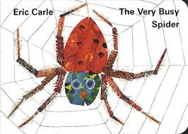
- Start by sharing the story if you have a copy of the book.
You could also watch the animated story on youtube. https://www.youtube.com/watch?v=TfL0g-XRxnA

- When your child knows the story really well, you could use this video with the sound muted and let them either tell the whole story or say the repeated line ‘She was very busy spinning her web’
https://www.youtube.com/watch?v=ZEGqru5vqsQ

- Draw one picture of an animal from the story on a post-it note or small piece of paper. Put them all in a bag and let your child pick one out. They can then do the action for that animal e.g. horse – pretend to ride, sheep - pretend to run. Let them tell you which action they are doing. If they can’t remember the word you could say e.g. ‘You’re rolling’

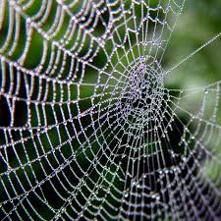
- Draw a story map (pictures that show what happened in the story in order) and then use it to re-tell the story together.

- When you are outside look for spider webs and talk about where you found them. You could also take photos then later ask your child ‘Where was this web?’

- Look on the internet at some photos of real animals that are mentioned in the story. Help your child to learn the names for parts of the different animals e.g. tail, mane, hooves, paws, wings, feathers, beak, horns.

- Talk about the word busy. What do the people in your house do when they are busy? Use the word lots of times throughout the day to talk about what everyone is doing.

- Sing ‘Old MacDonald had a farm’ and encourage your child to join in with the animal noises. https://www.youtube.com/watch?v=_6HzoUcx3eo
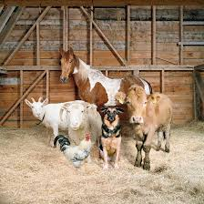
Here are some links to games where you can listen to the animal sound and guess which animal it is. https://www.youtube.com/watch?v=gkAsTg7Qvyw

https://www.youtube.com/watch?v=uF74DU34q2Y

You could also use toy farm animals or pictures of animals. You make the animal noise and your child chooses the right animal.



